Add Custom Field to Standard OData Service

1. Access Fiori App “Custom Fields and Logic”:  
   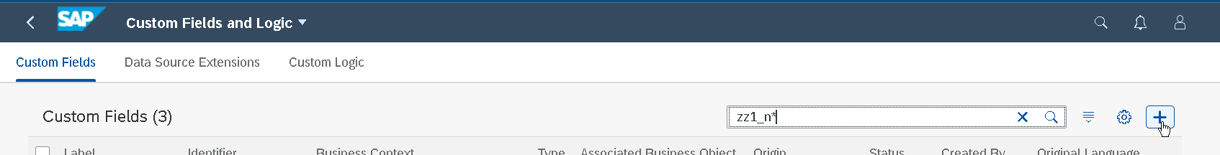
2. Give the details of the Field:  
   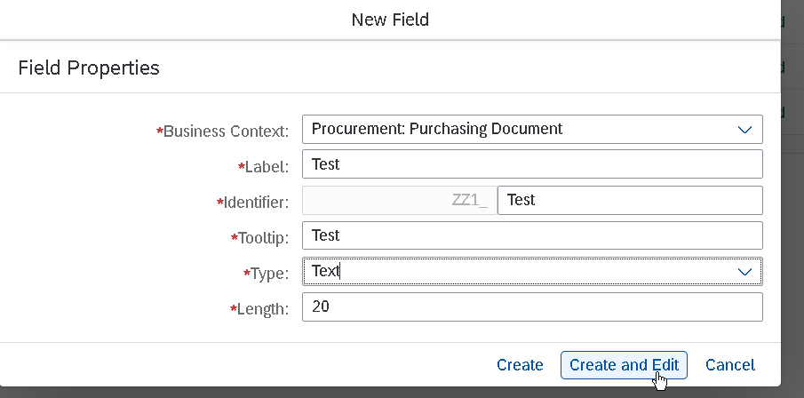
3. Check if your API is under the OData tile or the UI and Reports. Then click at Enable Usage:  
   Graphical user interface, text, application, email, Teams

   Description automatically generated
4. Save and Publish 
5. Navigate to App Register Extensions for Transport:  
   Select your Field and assign it to a Transport Request. Change packages if needed:  
   Graphical user interface, text, application

   Description automatically generated
6. Now go SEGW and create a project. By convention take the name of the Standard API and give it a “Z” in front of the name.
7. For the Data Model, Redefine it by picking the OData Service SAP GW options:  
   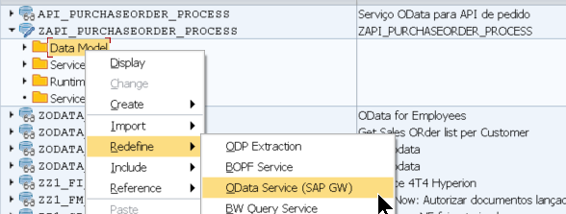

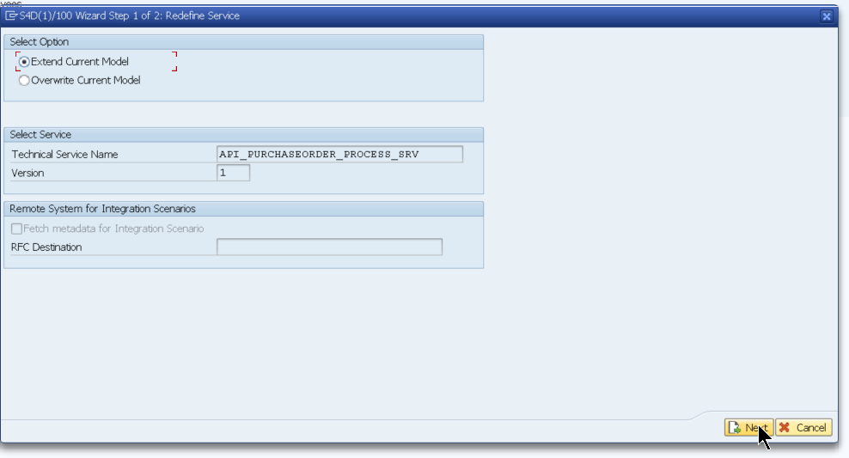

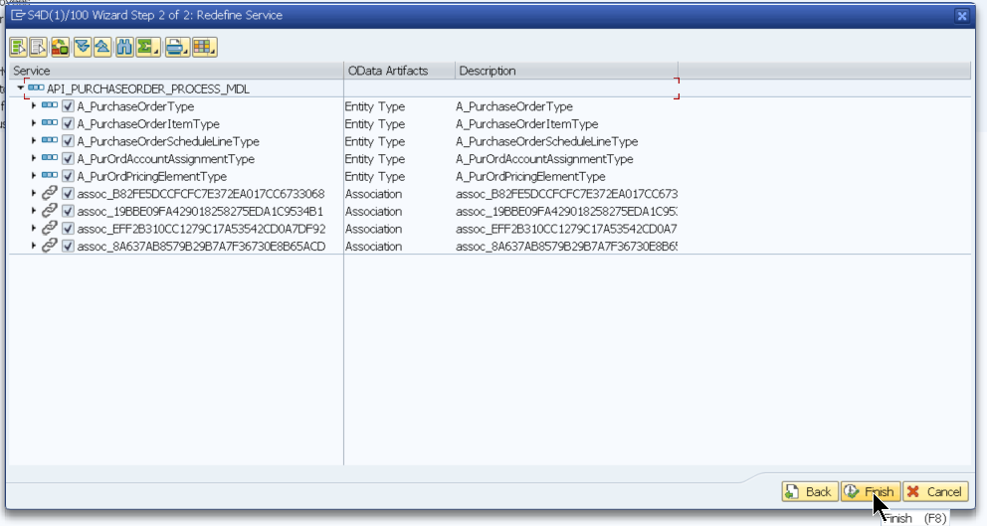

Generate it 

Overwrite Base/Extend Service by checking the box:

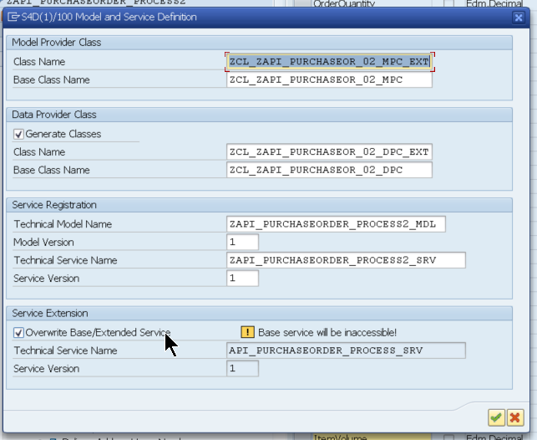

1. Create your logic in the DPC_EXT class, example

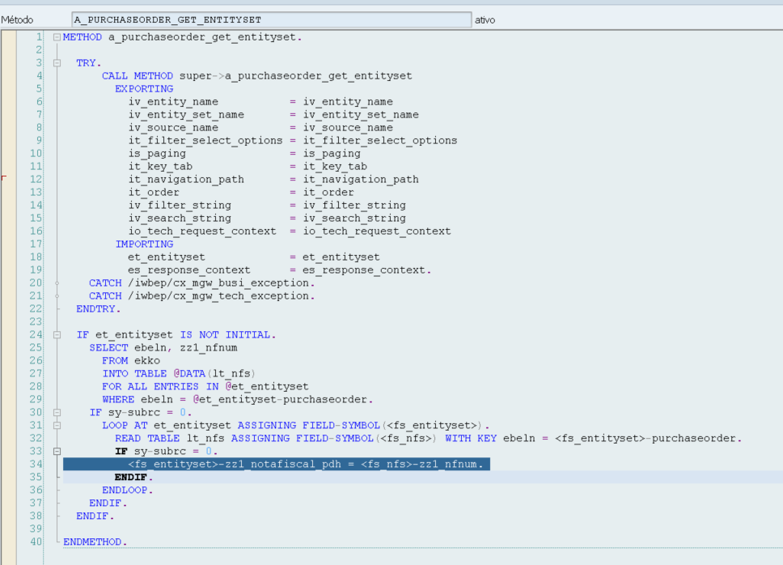

1. Save and activate everything
2. Test it:

